## Computer Networks

## Assignment 2

## Akshat Patil

## AIDS-A

## Roll: 10

## Prn: 12311353

### Wide Area Network (WAN)

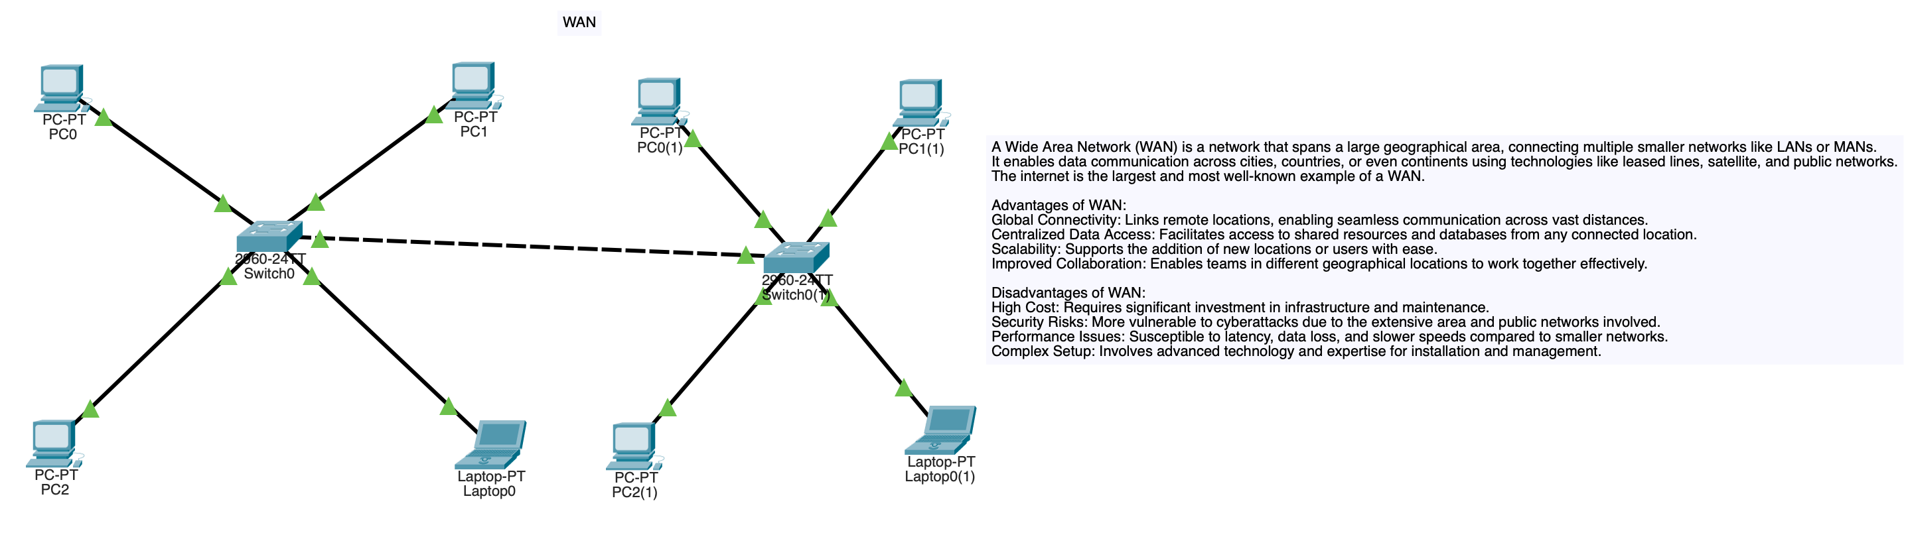

A Wide Area Network (WAN) is a network that spans a large geographical area, connecting multiple smaller networks like LANs or MANs.

It enables data communication across cities, countries, or even continents using technologies like leased lines, satellite, and public networks.

The internet is the largest and most well-known example of a WAN.

**Advantages of WAN:**

Global Connectivity: Links remote locations, enabling seamless communication across vast distances.

Centralized Data Access: Facilitates access to shared resources and databases from any connected location.

Scalability: Supports the addition of new locations or users with ease.

Improved Collaboration: Enables teams in different geographical locations to work together effectively.

**Disadvantages of WAN:**

High Cost: Requires significant investment in infrastructure and maintenance.

Security Risks: More vulnerable to cyberattacks due to the extensive area and public networks involved.

Performance Issues: Susceptible to latency, data loss, and slower speeds compared to smaller networks.

Complex Setup: Involves advanced technology and expertise for installation and management.

### Ping command from PC_PT PC1 ——> PC-PT PC0(1)

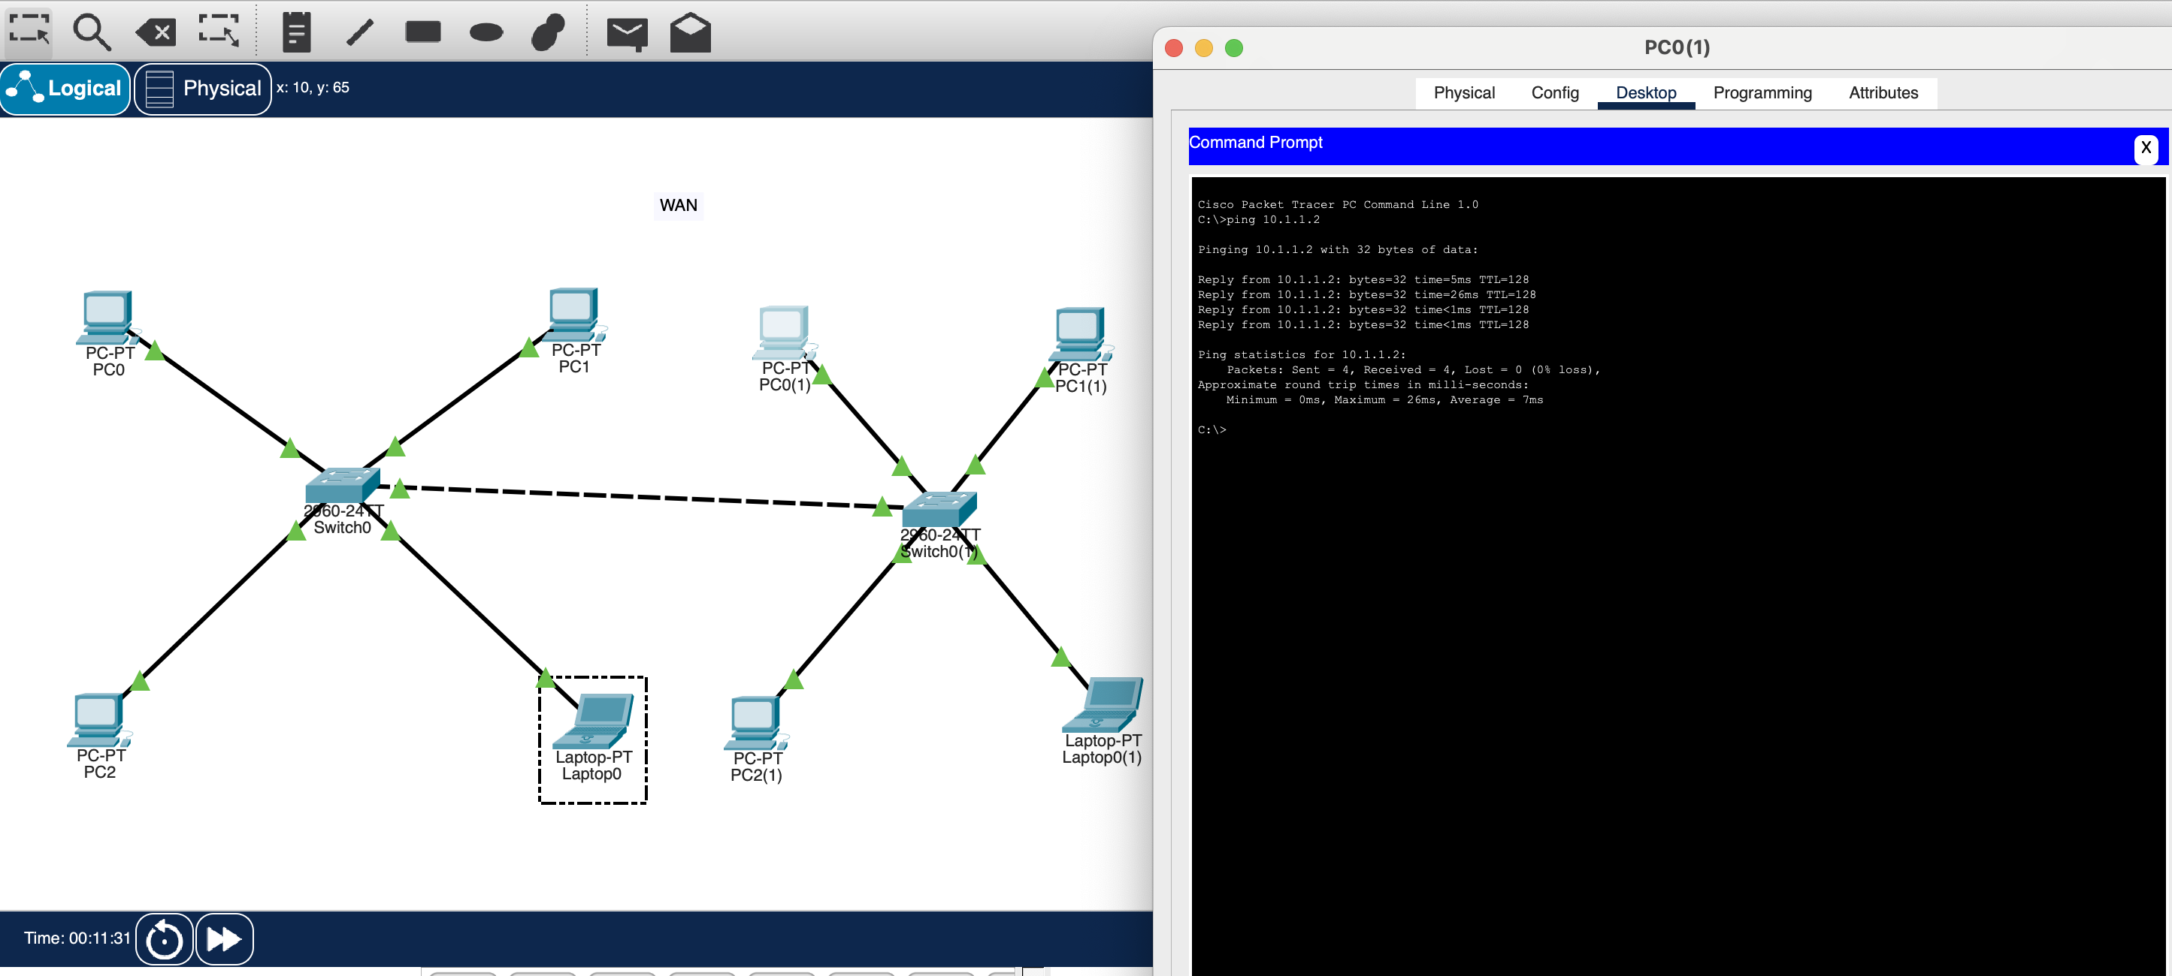

### Network Topology

Network topology refers to the arrangement of devices (nodes) and connections (links) within a network. It defines how devices communicate and interact with each other.

Examples:

1. **Bus Topology:** All devices connect to a single central cable; simple but prone to failure.

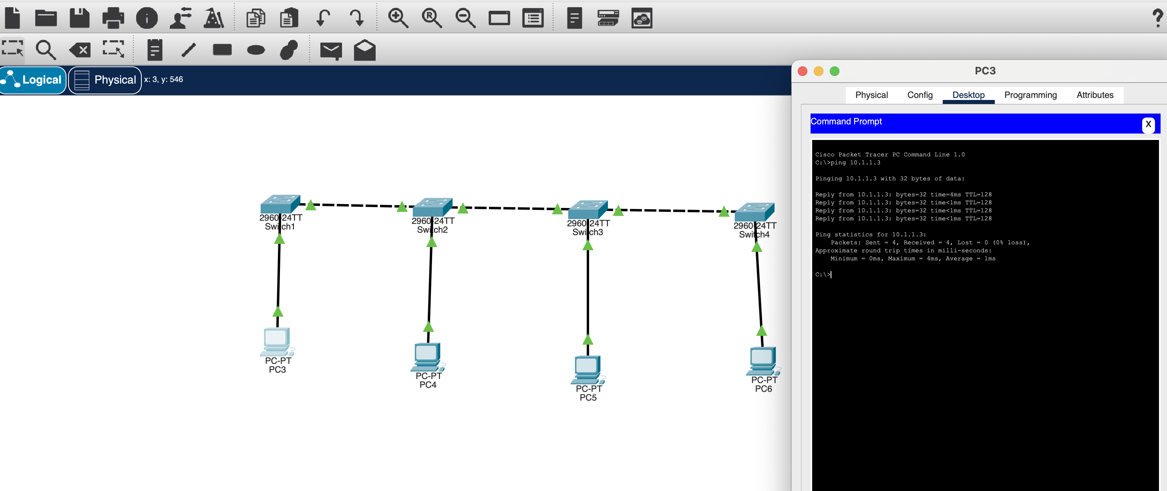2. **Star Topology:** Devices connect to a central hub; reliable but dependent on the hub.3

3. **Ring Topology:** Devices connect in a circular fashion; efficient but one failure can disrupt the network.

### Bus Topology

Diagram of bus topology network with ping command from PC-PT PC3 —> PC-PT PC6